 Site Amendments

Sign Up

Sign up presently does not allow for the input of decimal values for height and weight.

For height it wanted either 1 or 2 metres

For weight it woudn’t accept 83.5 Kg

Present Dashboard

My activity score seems to be working but not my sleep score.

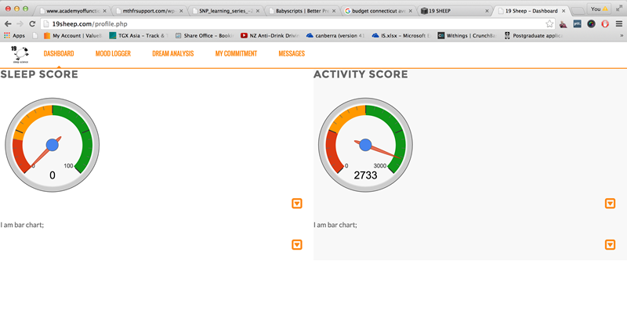

Please adjust as follows

Change BG of activity area to white.

Change colour of orange horizontal line to white

Reposition sleep and activity score columns to the right so level with menu.

We need to have a consistent menu at the top - it keeps changing depending what page we are in.

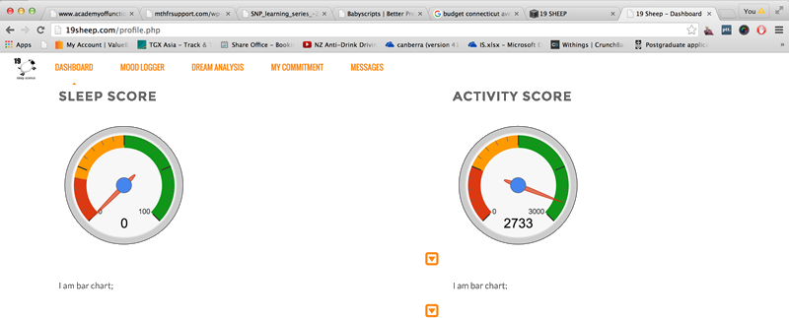

Dream form

Please remove the reset button.

Please shift the submit button to the left and remove the solid green colour from the button.

Please add a check box next to the submit button - I would like 19 sheep to assist me interpreting this dream.

Add another button ‘Log another dream’.

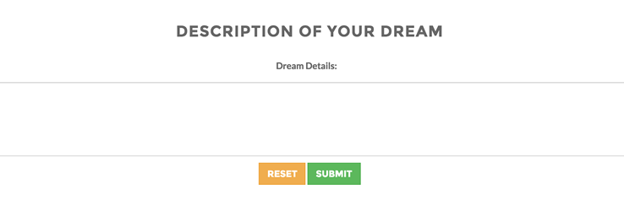

Dream form

Please remove the reset button.

Please add a button make another commitment

Please remove the solid colour from both of the buttons.

Please remove text ‘Provide more detail’.

Please remove the grey box border.

I couldn’t get the commitment form to work.

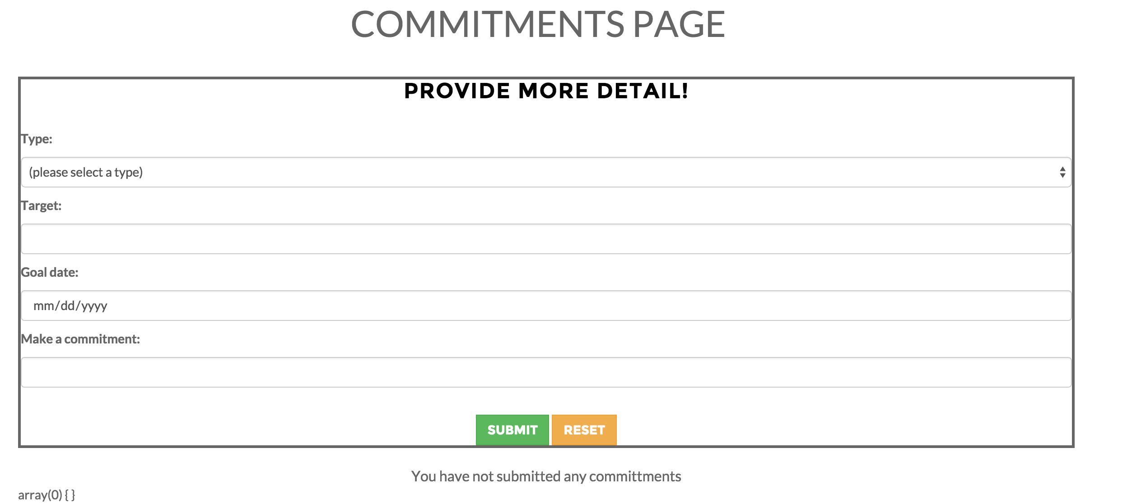

Mood logger

Here’s an idea for a mood selector animation

<http://bennettfeely.com/csscreatures/>

CSS Creatures are generated from 100% all-natural HTML5 and fresh-squeezed CSS3

They are really cute. We could configure them for the different moods and then have the user interact with them?

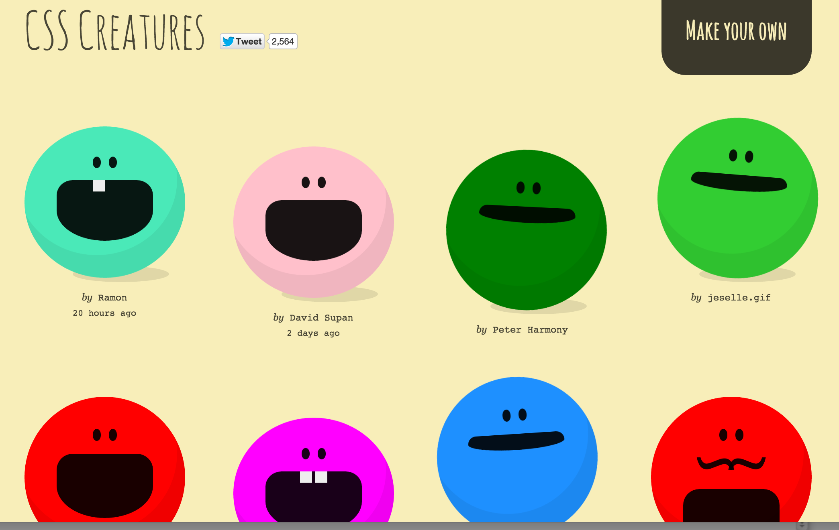

I am chatting with developer about using them on the site.